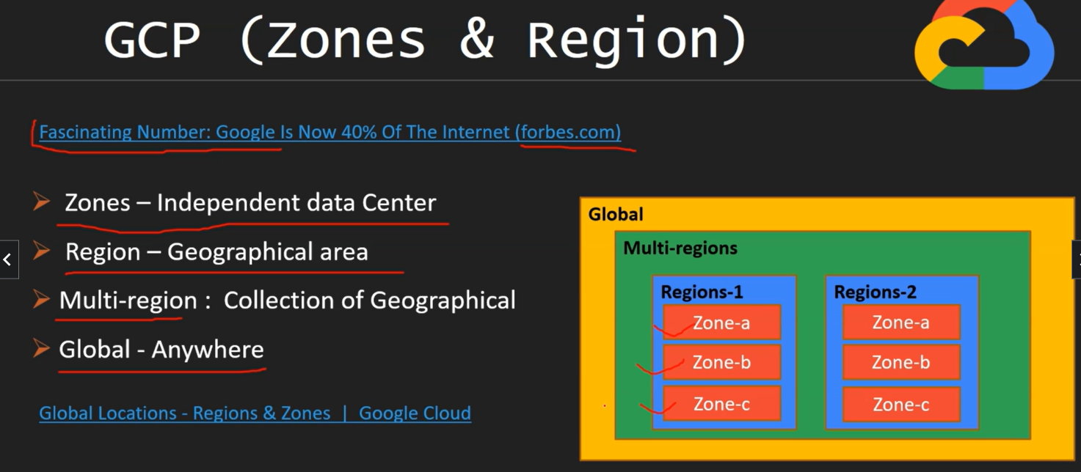

<https://cloud.google.com/about/locations#regions>



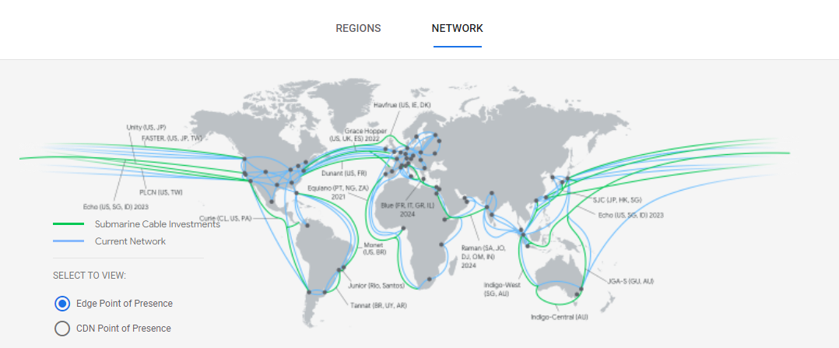

Docker installed in our cloud shell .

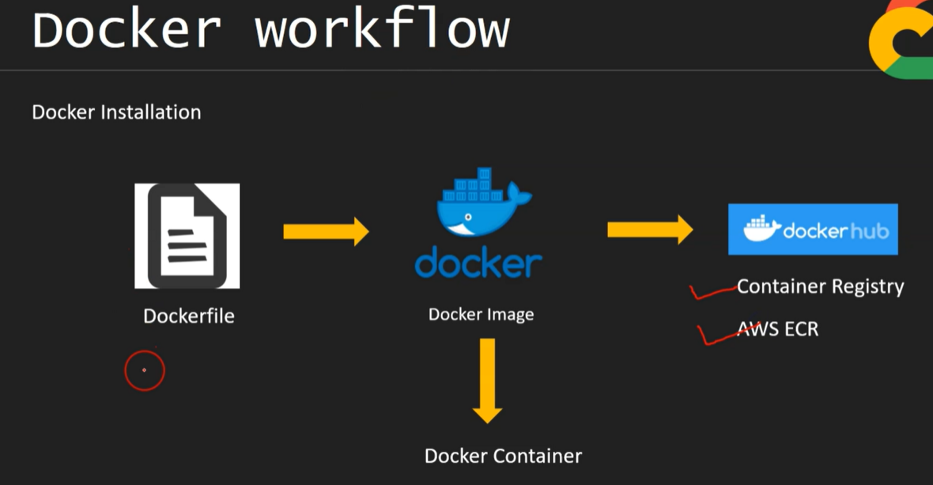

1)Base image – linux (as cloud shell )

2) Python docker image

3)Start flask web app

Main.py🡪

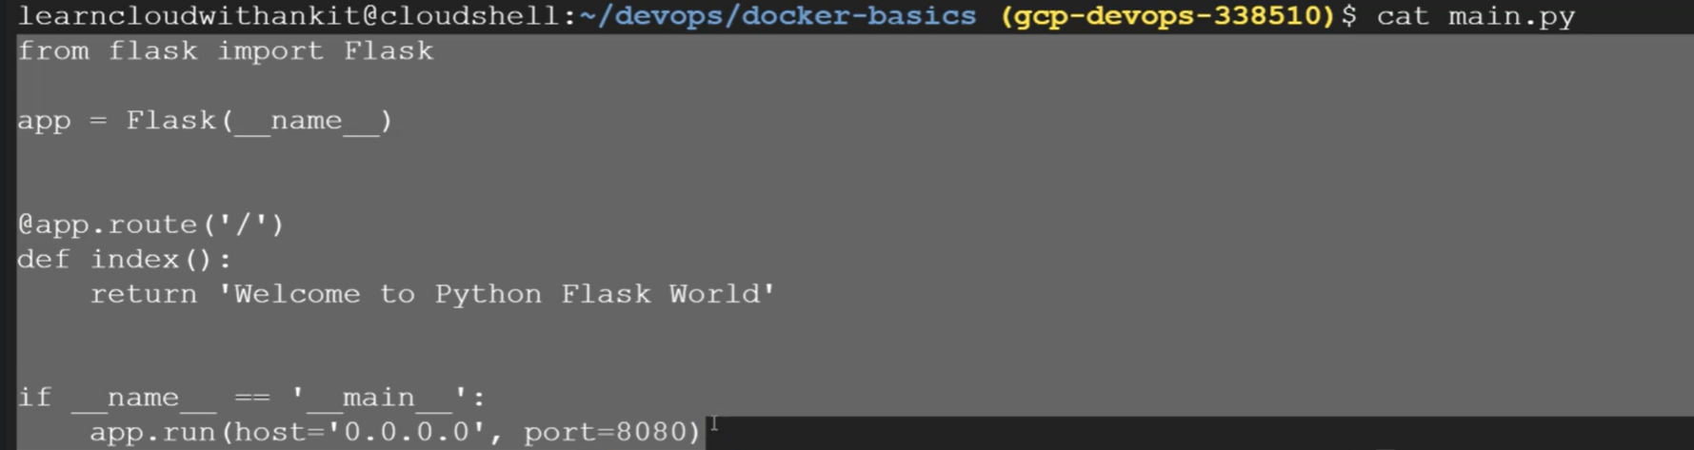

Dockerfile🡪

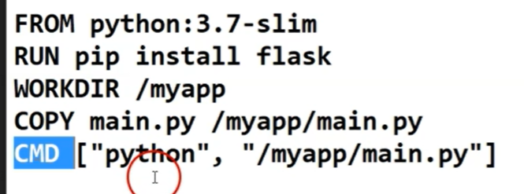

PS1=$ 🡪 for removing full dir path .

docker build -t gcr.io/gcp-projectid/myimanename .

(.) mean here current dir

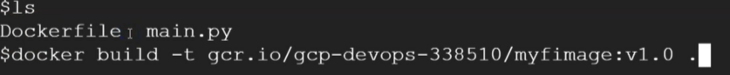

Need to register our image in google container registery (gcr.io) with name tag.

What ever I wrote in dockerfile it would be part of the image and store in gcr.io.

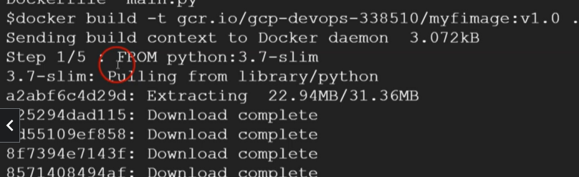

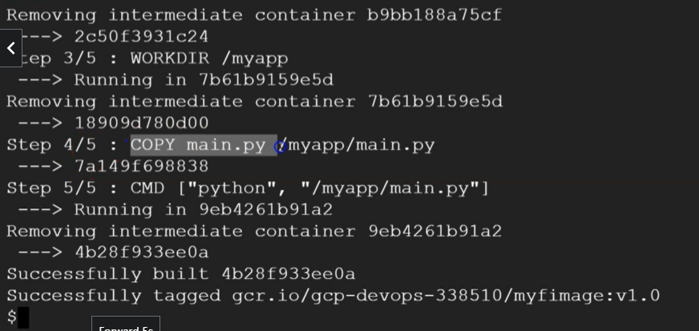

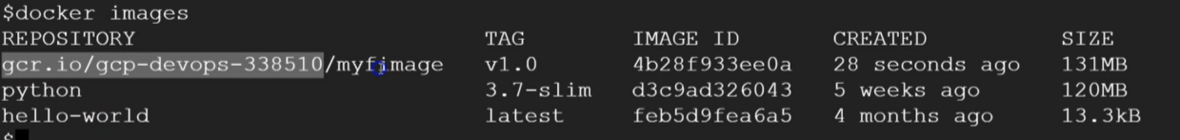

Now run my container 🡪

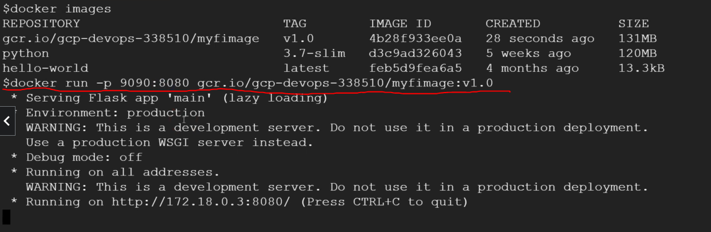

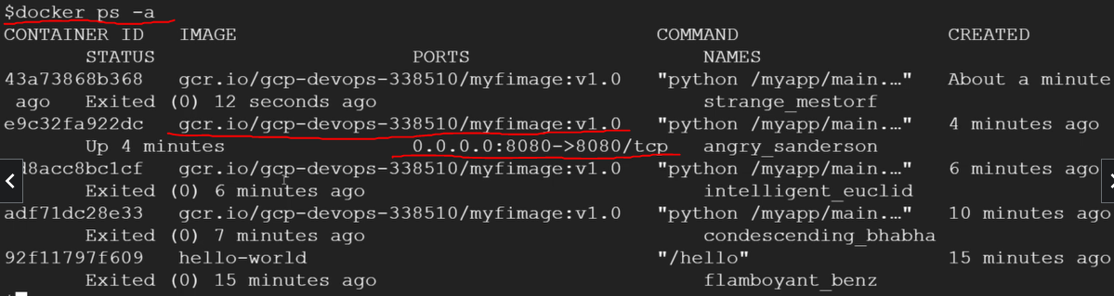

We can not remove running container

So stop firsrt

Docker stop containerid



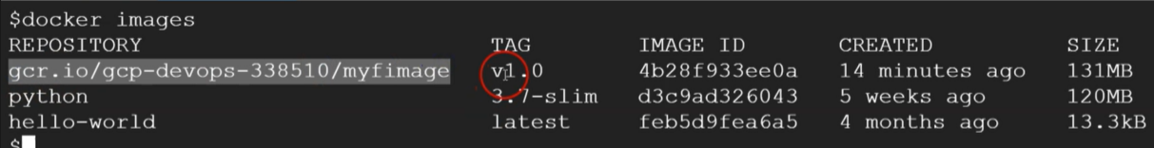

Google container registry🡪

Need push our container in GCR

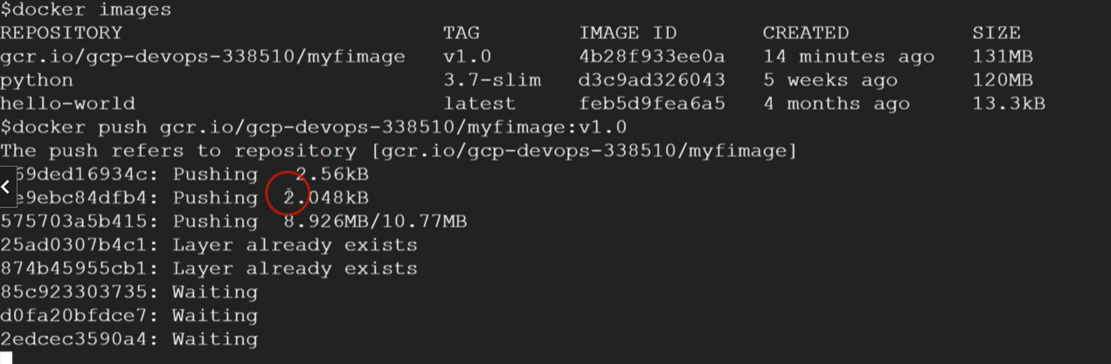

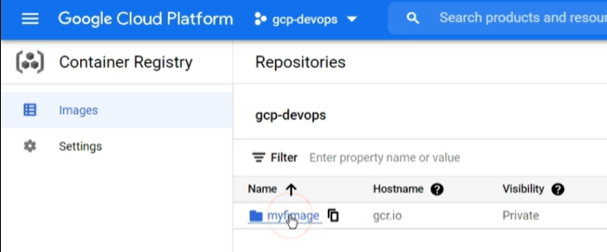

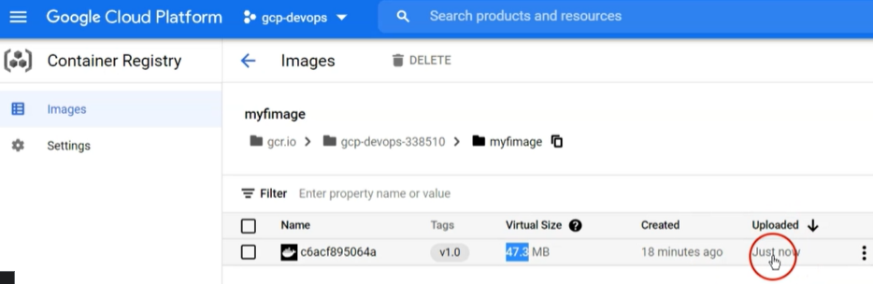

<https://cloud.google.com/run/docs#use-cases>

we can create multiple image with using same dockerfile with modify some in main.py file .



And Push it in gcr.io



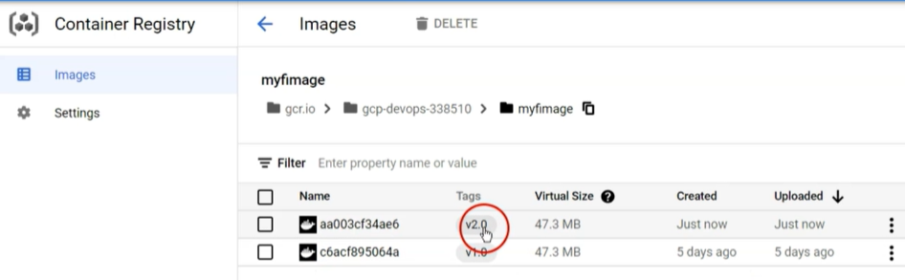

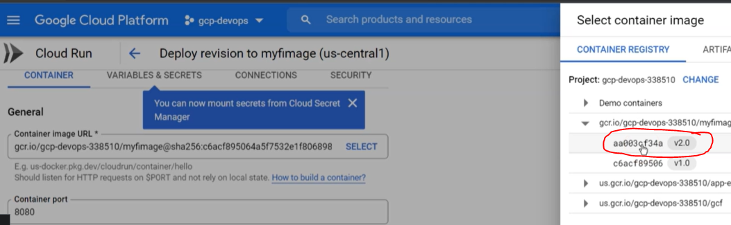

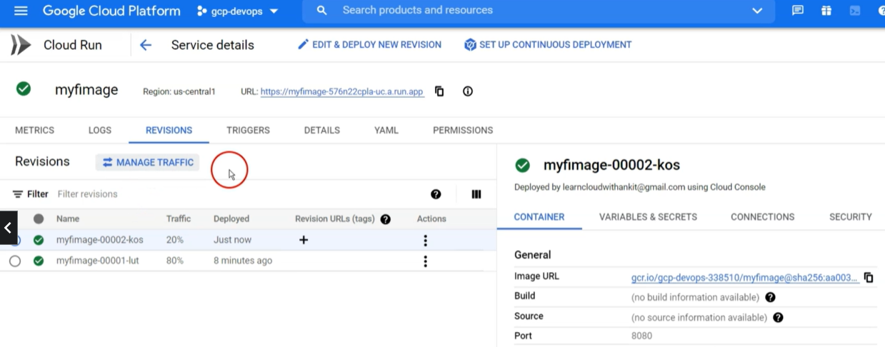

Kubernetes 🡪

1. Create a cluster with VM.
2. Deploy our docker image

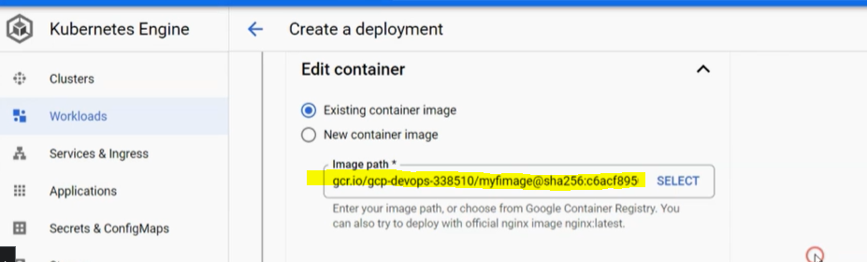

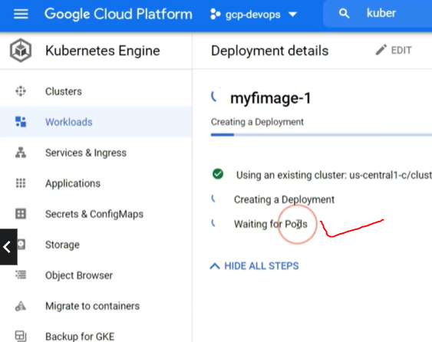

Three pods are running

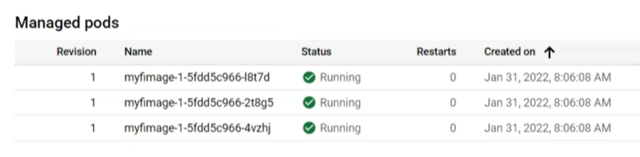

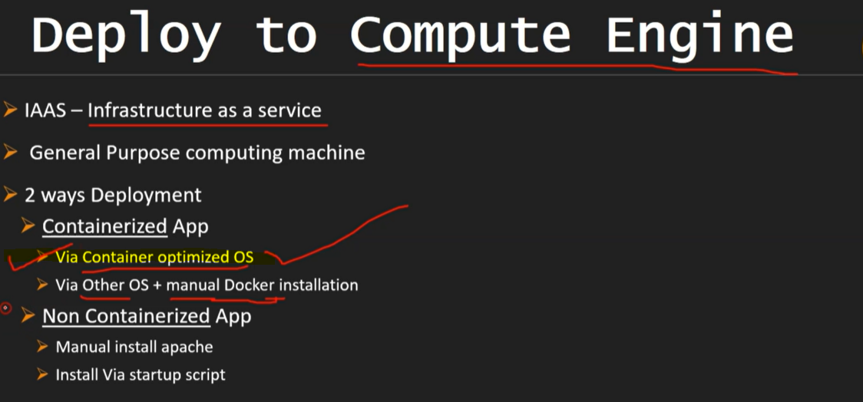

Deploy our docker image in GCE 🡪

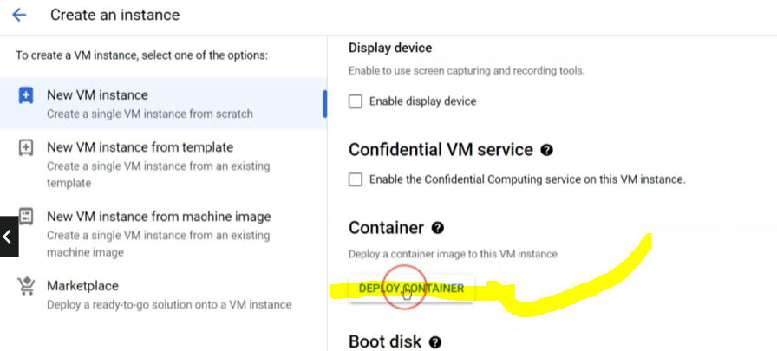

Copy your docker image path

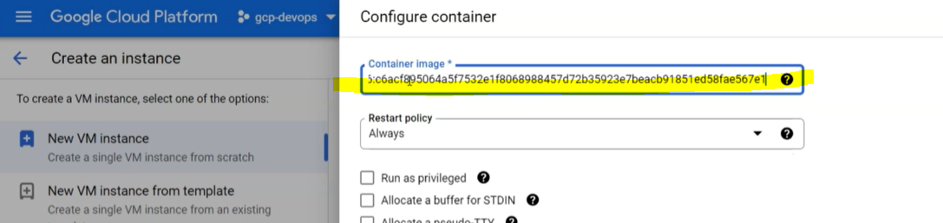

In GCE is using VM .

It is container-optimized OS so Boot dick having installed docker .

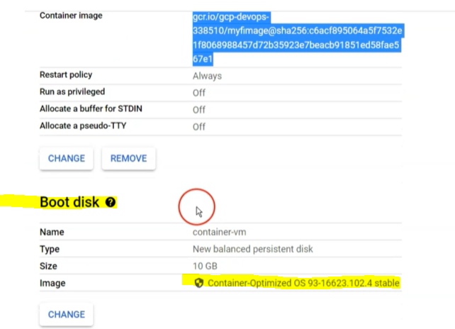

Boot Disk🡪

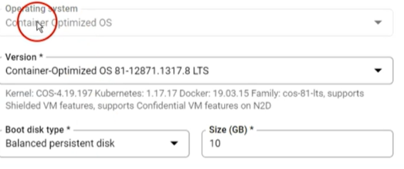

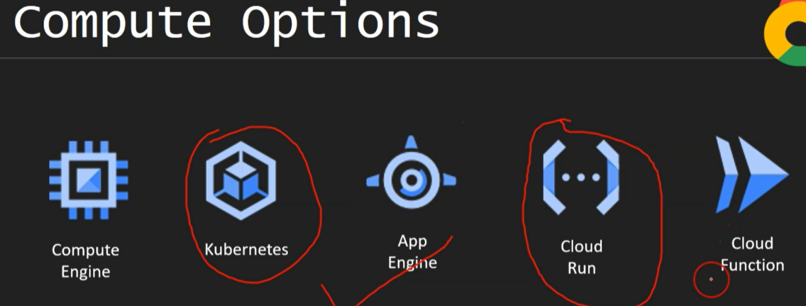

Execute your docker container/image 🡪

Docker exec -it containername bash

Docker-compose 🡪

We need to create docker-compose.yml file

Docker-compose –env-file .env up

.env file has below 🡪

Mysql_root